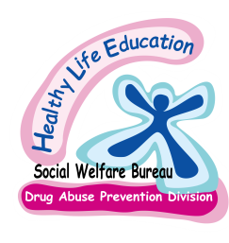
Healthy Life Education English Programme (2019/2020)
Details for making arrangement

When scheduling the classes, it can be flexible to meet the needs of teachers and the school timetable. The following points are for a reminder.
New multi-media equipment system

- Topic for each year:
Class | Topic | Time required
Kindergarten (K3) | Harold’s Picnic | One hour
Primary One | Air to Live | One hour
Primary Two | Food for Life | One hour
Primary Three | Great to be Me | One hour and twenty minutes
Primary Four | Body Network | One hour and twenty minutes
Primary Five | Clear the Smoke | One hour and twenty minutes
Primary Six | My Choice | One hour and twenty minutes
Note: We provide multi-media equipment system for P4~P6 classes to bring a new experience for students.
- Please make the arrangement from March to May in 2020.
- No. of students: maximum 50 people.
- Students are suggested to wear sports uniform since they will be asked to sit on the carpet. If necessary, chairs are provided.
- Teachers’ participation will be appreciated. They could help in the follow-up activities.
- Teachers need to bring the students name list when attending the lesson.
- Please communicate with The Education and Youth Affairs Bureau for students insurance as a school organized outdoor activity.
- For those schools which require bus service, the responsible bus company will confirm the time and location for fetching the students before the attending date. Please contact the educator if the bus company did not reach you.
- If school cancel the classes on the attending date, the school authority will be responsible to pay the traffic expenses.
- Please call and confirm after you fax the application form.
Contact person : Miss Vivien Lao (Phone number: 83997502)
Miss Claudia Cheung (Phone number: 83997505)

Fax number : 2822 5780 Website: http://healthylife.ias.gov.mo

Address : Rua Nova da Areia Preta, no.577, Edifício "The Bayview", r/c . Macau
(Healthy Life Education Centre)

Filled in by EVS
Code：__________________
Respondent：___________
Date： _________________
Healthy Life Education English Programme (2019/2020)
Application Form (March to May)

School name: ______________________________ Principal name: ______________________

School address: (English)_________________________________________________________________________

(Chinese) ________________________________________________________________________

School phone no. : ____________ Fax no. : ____________ E-mail address:________________

Contact person: ____________________ Post: __________________Phone no: ____________

Date (yy/mm/dd) | Time | Class | No. of students | Teacher’s name
 | to
 | to
 | to
 | to
 | to
 | to
 | to
 | to
 | to
 | to
 | to
 | to

Please read the “Details for making arrangement” before application and fill in class time according to the date order.

Please“✓”︰Bus Service School Bus

Remark: __________________________________________________________________

Principal’s signature: _______________________ School Chop: ___________________

Date of Application: ___________________( Year / Month / Date )

(This form can be copied)

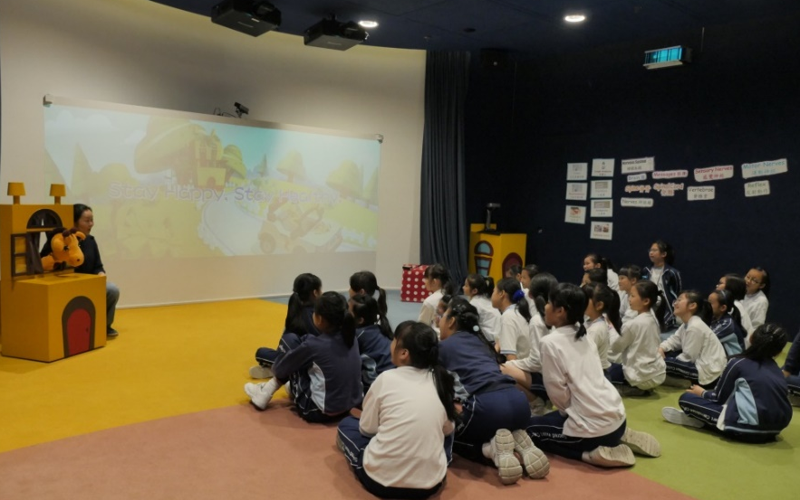
(P4~P6)
New multi-media equipment system

P4: Body Network |  |  | P5: Clear the Smoke
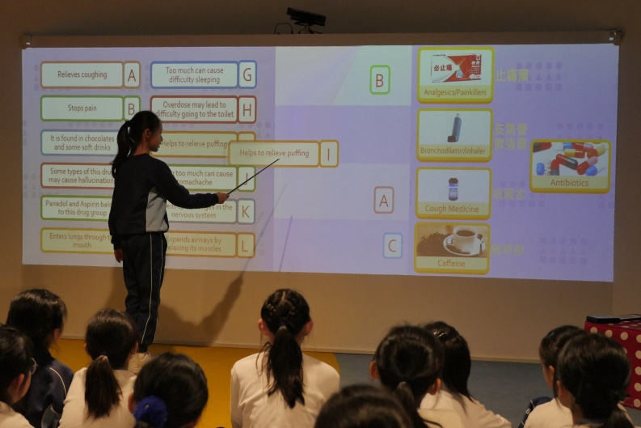 |  | 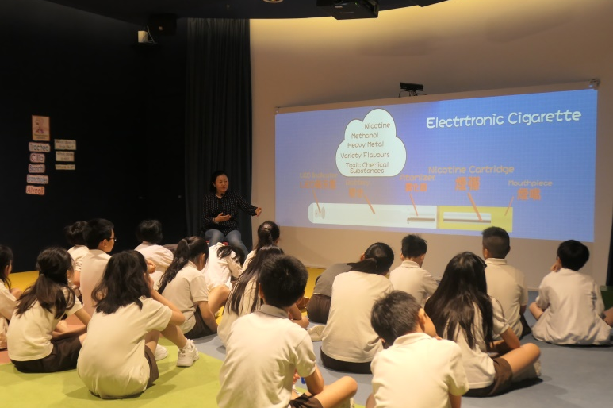
Drug Matching |  | Electronic Cigarette
P5: Clear the Smoke |  | P6: My Choice
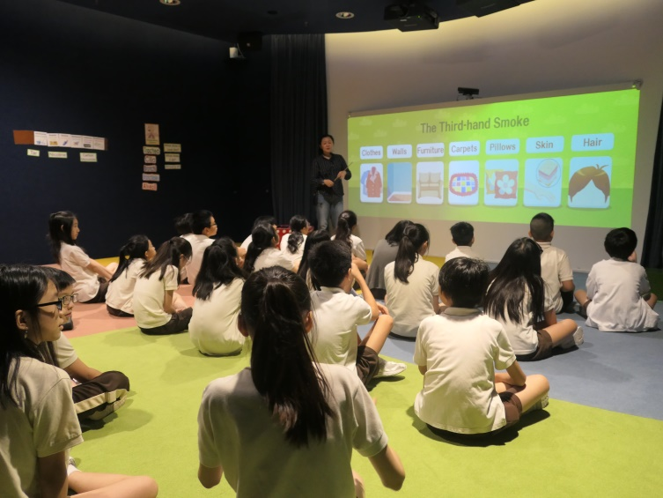 |  | 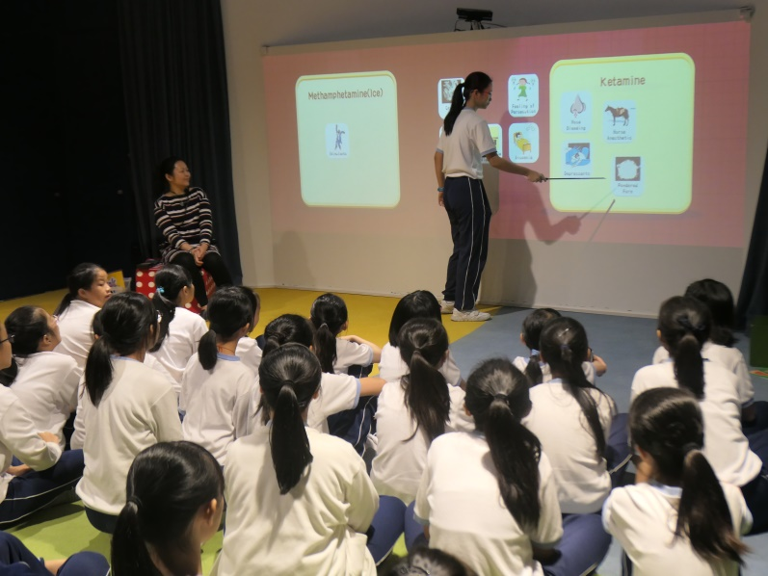
Third-hand Smoke | Drug Classification

